**HOTEL ANALYSIS**

Hi there! My name is **Oluwakemi Dorcas Samuel** and I'm working as a data analyst for this hotel. My task is to perform a thorough analysis of the hotel booking data and provide actionable insights that will assist the company in making strategic decisions. After carefully studying the data, I'm confident that my analysis will help the company reach its goals.

**INTRODUCTION**

I analyzed the hotel booking data using Excel. The data includes bookings for hotels. This information provides insight into both hotels' booking patterns and comprehensive information on the bookings. By analyzing this data, we can identify important trends in hotel bookings and answer various questions about the industry.

**DATA SOURCING**

I downloaded the data set in CSV file format from the company's database and imported another segment directly from the web to complete the data set. So now I have two different sets of data.

**DATA PROCESSING**

The CSV data was extracted and converted into .xlsx format. Microsoft Excel was used for data preparation, exploration, and visualization. I chose this tool because of its versatility and data organization functions, making insight generation easier.

The vlookup function was used to fill in the column for the country name from the CSV file scrapped from the web, the original data only had country codes. Other data cleaning operations such as filtering, finding in replacing values, removing duplicates, etc. were done. Pivot tables were used majorly for the analysis.

**RESULTS (Reservation Overview)**

**1. Total Number of Guests**

According to the bar charts, the total number of guests shows that Adults have a high number with 221636 and children have several 12403.

**2. Total Number of Guests According to Hotel Type**

Based on the hotel type, City hotels have the highest number of 154478 guests compared to Resort hotels, which have a total of 80510 guests.

**3. Reservation by Customer Type**

Using Excel's charting features, I was able to generate a bar chart that shows how reservations are distributed among different customer types. From the chart, it is evident that the majority of bookings are made by "Contract" customers, and the second most common booking type is "Group". "Transient" and "Transient-Party" bookings, on the other hand, make up a smaller percentage of the total reservations.

4. **Reservation by Year**

I found it helpful to use Excel's funnel chart feature to visualize the reservation process over several years. This chart shows the booking lifecycle and how it has changed with time, with the highest number of bookings occurring in 2014 and a steady decline since then. It's important to understand how the booking lifecycle has evolved, and the funnel chart makes it easy to see this information.

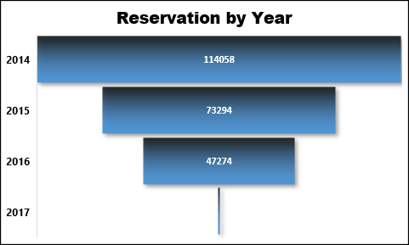

5. **Reservation by Market Segment**

Excel can create a tree map that shows reservation distribution by market segment. Each box's size represents the number of reservations for that segment. This tool is crucial in identifying dominant market segments, such as "Aviation" and "Complementary."

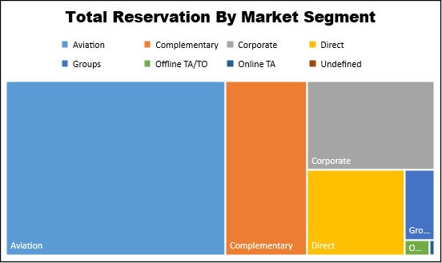

6. **Total Reservation by Country**

By using Excel's line graph feature, I was able to visualize the number of reservations made by country over time. The line graph shows that most bookings are from Peru and Qatar, but there is also a significant international presence.

**7. Monthly Reservation by Customer Type**

Using Excel's monthly line graph feature, I can examine the fluctuations and patterns in reservation behavior of different customer types throughout the year. The visual representation of the data shows that "Transient" customers are consistently the dominant group every month.

8. **Distribution Channel and Reservation Slicers**

By leveraging slicers to filter data by the booking channel or reservation status, you can gain deeper insights into customer behaviors and booking patterns. This analysis serves as a valuable resource for hotel management to make data-driven decisions and improve their booking strategies.

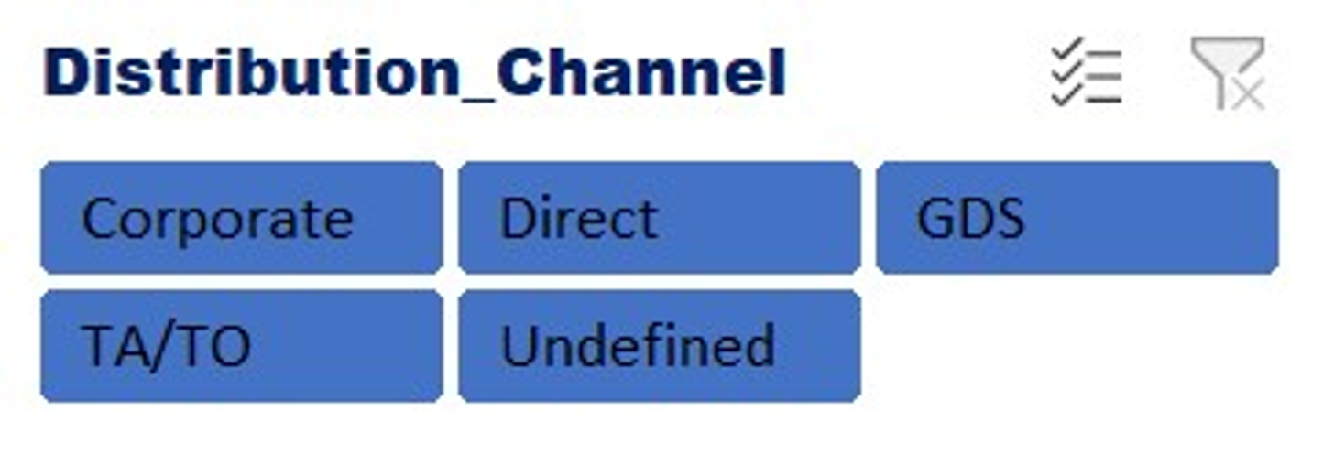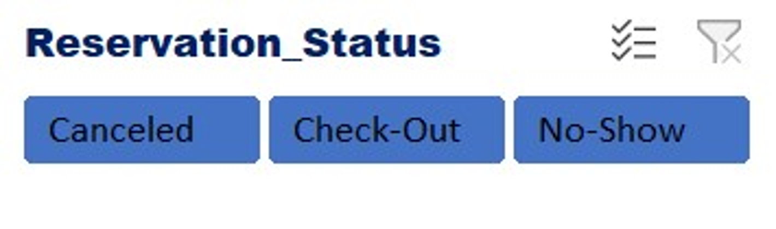

**Recommendations**

1. To attract more bookings, it's important to focus on the majority customer type. Marketing campaigns and services should be tailored to their preferences and needs. Additionally, incentives such as discounts or benefits can be offered to encourage group bookings and increase overall bookings. Furthermore, the same efforts should also be applied to the market segments.

2. To better understand the reasons behind the yearly decline in customers, the company should gather more data and analyze a wider range of values. This could include factors such as customer satisfaction and dissatisfaction, feedback, and reviews. Prioritize exceptional experiences for both adults and children by improving service quality and resolving complaints

3. Although local bookings are important, it's also crucial to recognize the possibilities presented by international markets. To attract more international guests, it's recommended to focus on localized marketing efforts and services.

4. Based on the reservation data, it appears that the hotel had the contract customers had the most bookings overall, but when looking at canceled reservations specifically, they also had the highest number of cancellations. In contrast, the transient bookings were very low, but they had the highest number of monthly reservations and bookings. It may be beneficial to focus on improving services for transient customers to receive positive reviews and attract more customers. Additionally, loyalty cards with benefits should be given to regular customers.

5. To increase reservations for the hotel, it's important to focus on managing and improving distribution channels. It's advisable to dedicate more resources and marketing efforts toward the most effective channels to optimize revenue and bookings. The GDS channel appears to be the most successful, so it's important to enhance it to ensure a steady flow of bookings.

6. To maintain steady revenue year-round, it is recommended to strategize promotions and tailor offerings for both peak and off-peak seasons. This can be determined by analyzing the customer line graph, which typically shows the peak period occurring in the middle of the year, likely during the summer months.

**Questions.**

1. Scrape the web for the following columns: Country, country codes (alpha-2 and alpha-3), and Numeric into an Excel sheet and save the file as Country Codes.

2. Vlookup Country from Country Codes (Excel sheet created above) into Hotel Bookings Excel Sheet (insert the Country names in column O).

3. Create Pivot tables to summarise your dataset by the following:

i. Hotel reservations by hotel_type, and total reservation

ii. Total reservations by Market segment; sort by largest to smallest.

iii. Trend of total reservations by reservation status by year

iv. Trend of Total reservations by customer type and by month

v. Total reservations by Country, sorted by largest to smallest.

**DASHBOARD**

Create a dashboard from the Pivot tables above, including Slicers for Market segment, distribution channel, and customer type.

On this dashboard, you can view the reservations that have been cancelled. The Contract customer type had the highest number of cancellations. However, without using the slicer, the highest number of reservations made showed contracts to be the highest. A screenshot of a hotel dashboard

This visualization shows the distribution channel that had the highest reservations made by customer type.

